Epsom & Ewell
21
v
FC Deportivo Galicia
Tuesday, 12th March 2019 – 7.45 p.m.
Good evening and welcome to the players, supporters and officials of FC Deportivo Galicia who are making their first visit to us, looking to prevent a League double following our 3-0 win at the Bedfont Sports Club back in September.

It’s been a while since we have been at High Road and we have had four away matches, all of which have regrettably ended in defeat. We defeated British Airways 3-2 in our last appearance here but four days after that we lost our 11 match unbeaten record with a 4-2 loss at the Met Police Academy in the Surrey Premier Cup at Imber Court and it has to be said they were just a little better than us on the night.

Following that we visited Frimley Green and were bullied out of it with the scoreline of 4-2 not really doing justice to their dominance on the day.

We then had a ten day break before visiting Abbey Rangers in the League Cup Quarter-Final and despite a good first half performance, three quick goals early in the second half ended our interest despite a late rocket from Rob Hendry that made the final score 3-1.

Finally on Saturday we visited Leatherhead’s Fetcham Grove ground for a League match against Kensington Borough and had a bit of a disaster, conceding five times in the opening half and eventually losing 5-1. This second half goal from Ben Chick means that we have scored in every league match this season still and with seven matches remaining, I wonder whether we can keep that record up!

We off again this Saturday, although next Tuesday we have an important trip to Woking Football Club to face Sheerwater. We then have an eleven day break before visiting Raynes Park Vale for another big league match at Tooting Bec. The Semi-Final of the League Division One Cup has not yet been advised, so please keep checking the website for details of our final chance at silverware.

For those who were unaware we have had quite an eventful couple of weeks towards the end of February. We were chosen by the F.A. in conjunction with PayPal to be the face of a new MatchDay app and many of our players took the day off and were filmed alongside former Internationals Rachel Yankey and Lee Dixon. The full story appears further on in the programme.

We thank Alex McKay Senior for his sponsorship today. We have many players and just one match left for sponsorship, so don’t be shy, just speak with a Committee member for details. You know where we are!

Enjoy the game!

Rich
You can follow us on social media – just look at the inside cover for details.

Cover photos

- Club photo from 20th February with Lee Dixon and Rachel Yankey, but why?
- & 3) Other pictures from the same afternoon

Cherry Red Records Combined Counties League
Division One Table 2018/19
inc Saturday 9th March 2019 | P | W | D | L | F | A | Pts | GD | H | A

Frimley Green | 28 | 19 | 6 | 3 | 61 | 32 | 63 | +29 | 3-0 | 2-4
Sheerwater | 29 | 19 | 5 | 5 | 76 | 36 | 62 | +40 | 2-3 | 19/3
Bedfont & Feltham | 27 | 18 | 6 | 3 | 88 | 32 | 60 | +56 | 4-4 | 13/4
Farnham Town | 27 | 16 | 5 | 6 | 56 | 29 | 53 | +27 | 27/4 | 1-4
Epsom & Ewell | 27 | 16 | 3 | 8 | 67 | 48 | 51 | +19 | X | X
Tooting Bec | 26 | 14 | 7 | 5 | 58 | 30 | 49 | +28 | 3-1 | 30/3
Ash United | 28 | 13 | 6 | 9 | 68 | 58 | 45 | +10 | 1-1 | 2-1
Sandhurst Town | 25 | 13 | 4 | 8 | 42 | 40 | 43 | +2 | 20/4 | 2-0
Chessington & Hook Utd | 27 | 11 | 6 | 10 | 53 | 51 | 39 | +2 | 1-2 | 4-1
Dorking Wanderers Res | 30 | 11 | 5 | 14 | 57 | 70 | 38 | -13 | 3-0 | 3-5
British Airways | 28 | 11 | 4 | 13 | 62 | 68 | 37 | -6 | 3-2 | 2-3
Bagshot | 30 | 10 | 4 | 16 | 37 | 81 | 34 | -44 | 7-1 | 3-0
Godalming Town | 29 | 9 | 4 | 16 | 40 | 67 | 31 | -27 | 3-2 | 3-1
FC Deportivo Galicia | 27 | 7 | 3 | 17 | 47 | 57 | 24 | -10 | 12/3 | 3-0
Kensington Borough | 27 | 5 | 8 | 14 | 35 | 62 | 23 | -27 | 1-1 | 1-5
Eversley & California | 27 | 6 | 2 | 19 | 48 | 70 | 20 | -22 | 1-0 | 1-2
Cove | 29 | 5 | 4 | 20 | 39 | 66 | 19 | -27 | 3-2 | 2-1
Fleet Spurs | 29 | 5 | 2 | 22 | 44 | 81 | 17 | -37 | 6/4 | 3-2

AC London (removed) | 15 | 9 | 2 | 4 | 36 | 25 | 29 | +11 | - | 6-0

Lucky Day? – 12th March
Played 15 - Won 2 Drawn 5 Lost 8 - For 24 Against 37 - PPG 0.73 - Very Poor
We have not won on this date since 1932!
Our Club record against FC Deportivo Galicia
Played 1 - Won 1 Drawn 0 Lost 0 - For 3 Against 0 - PPG 3.00 - Perfect
Our Largest wins and losses against FC Deportivo Galicia
22nd September 2018 - W 3-0 - Combined Counties League Division One
FC Deportivo Galicia‘s Last Visit
This is their first visit

Simon Funnell
This evening we welcome FC Deportivo Galicia to High Road for our Combined Counties League fixture, hopefully we can pick up the points we need to stay in and around the top four.

We have some news on the player front over the last few weeks as three players have departed the club, Taryn Smith, Germaine Jeannoel and Roy Gayle. We thank them for their efforts and wish them well for the future.

Of our incoming players we have Sam Eastgate who has been training with us for a few months now and is coming back from a bit of time away from football and just moved to the area, George Brown is a young lad with great potential and is dual signed from Chipstead, while another young lad, Jake Robinson, also from Chipstead has already made three appearances for us. He has made quite a few first team appearances for Chipstead and scored a few goals and is another great addition to the squad. We welcome all three players.

Unfortunately we have lost a couple of games recently. The County Cup tie at Met Police was a tough game and we started very slowly and in the end that cost us to get knocked out of that cup.

Then we had a big game away to Frimley Green in the league and in probably the most important game of the season we decided as a team to not really turn up; the pitch was not great with a big slope and very bobbly, but I feel we got bullied by a big physical side and again had a poor start and found ourselves chasing the game. When we managed to get a foothold in the game it was too little too late.

Then we had a tough cup fixture away to Abbey Rangers from the Premier Division who are going along nicely in their league. At half time it was 0-0 and in my opinion I don’t think you could tell who the higher division side were. In the second half Abbey started the half better than us and I’m afraid to say we made it a bit too easy for them to take the lead and a bad 15 minutes ended up costing us the game. I don’t believe that they were 3-1 better than us on the night but they took their chances and I wish them well in the next round. (These comments were written before Saturday’s match at Kensington Borough - Rich)

As a lot of you may of seen we had Lee Dixon and Rachel Yankey down at High Road promoting a new phone app, and Richard goes into more detail later in the programme. It was a good day filming with about 10 of the players, plus Matt, Paul and myself. This is very good for our club and I think everyone enjoyed the day.

Enjoy the game tonight and let’s hope for a good result.

Simon

Recent Results and Fixtures
Surrey Premier Cup QF – Saturday 16th February 2019
Nottsborough | 1-1 - 7-6p | Sheerwater
Combined Counties League – Saturday 16th February 2019
Bedfont & Feltham | 1-1 | Tooting Bec
Dorking Wanderers Reserves | 1-5 | Cove
Epsom & Ewell | 3-2 | British Airways
Eversley & California | 5-6 | FC Deportivo Galicia
Frimley Green | 2-2 | Godalming Town
Kensington Borough | 1-1 | Ash United
Sandhurst Town | 1-1 | Chessington & Hook United
Combined Counties League Cup QF – Tuesday 19th February 2019
CB Hounslow United | 2-1 | Banstead Athletic
Knaphill | 0-3 | Bedfont & Feltham
Combined Counties League – Tuesday 19th February 2019
Fleet Spurs | 1-2 | Chessington & Hook United
Surrey Premier Cup QF – Wednesday 20th February 2019
Met Police Academy U23s | 4-2 | Epsom & Ewell
Combined Counties League – Wednesday 20th February 2019
FC Deportivo Galicia | 1-3 | Sheerwater
Combined Counties League – Saturday 23rd February 2019
Bagshot | 1-0 | FC Deportivo Galicia
British Airways | 2-4 | Sandhurst Town
Chessington & Hook United | 0-3 | Bedfont & Feltham
Fleet Spurs | 0-0 | Kensington Borough
Frimley Green | 4-2 | Epsom & Ewell
Godalming Town | 1-0 | Cove
Sheerwater | 1-1 | Dorking Wanderers Reserves
Tooting Bec | 2-0 | Farnham Town
Combined Counties League – Tuesday 26th February 2019
Cove | 1-1 | Farnham Town
Eversley & California | 3-0 | Fleet Spurs
Kensington Borough | 1-0 | Godalming Town
Combined Counties League – Saturday 2nd March 2019
Ash United | 2-1 | Fleet Spurs
Bedfont & Feltham | 5-0 | Godalming Town
Cove | 1-4 | British Airways
FC Deportivo Galicia | 1-3 | Farnham Town
Recent Results and Fixtures
Combined Counties League – Saturday 2nd March 2019
Sandhurst Town | 0-2 | Frimley Green
Sheerwater | 5-0 | Eversley & California
Tooting Bec | 3-0 | Bagshot
Combined Counties League Cup QF – Tuesday 5th March 2019
Abbey Rangers | 3-1 | Epsom & Ewell
Esoteric Division One Cup QF – Tuesday 5th March 2019
Tooting Bec | p-p | Frimley Green
Combined Counties League – Tuesday 5th March 2019
Eversley & California | 0-1 | Bagshot
Farnham Town | 2-1 | Sheerwater
Combined Counties League – Saturday 9th March 2019
British Airways | 4-1 | Ash United
Chessington & Hook United | 6-2 | Cove
Dorking Wanderers Reserves | 0-4 | Sandhurst Town
Farnham Town | 3-1 | Eversley & California
Fleet Spurs | 1-1 | Tooting Bec
Frimley Green | 5-1 | Bedfont & Feltham
Godalming Town | 0-3 | Sheerwater
Kensington Borough | 5-1 | Epsom & Ewell
Combined Counties League – Tuesday 12th March 2019
Bagshot | V | Sandhurst Town
Epsom & Ewell | V | FC Deportivo Galicia
Kensington Borough | V | Eversley & California
Combined Counties League – Saturday 16th March 2019
Bagshot | V | Cove
British Airways | V | Godalming Town
Chessington & Hook United | V | FC Deportivo Galicia
Eversley & California | V | Dorking Wanderers Reserves
Fleet Spurs | V | Farnham Town
Sandhurst Town | V | Ash United
Sheerwater | V | Bedfont & Feltham
Tooting Bec | V | Frimley Green
Combined Counties League Cup QF – Monday 18th March 2019
CB Hounslow United | V | Hanworth Villa
Combined Counties League – Tuesday 19th March 2019
Sheerwater | V | Epsom & Ewell
Recent Results and Fixtures
Combined Counties League – Tuesday 19th March 2019
Tooting Bec | V | FC Deportivo Galicia
Combined Counties League – Saturday 23rd March 2019
Ash United | V | Cove
Bedfont & Feltham | V | Farnham Town
Dorking Wanderers Reserves | V | Chessington & Hook United
Eversley & California | V | Sandhurst Town
Frimley Green | V | British Airways
Godalming Town | V | Fleet Spurs
Kensington Borough | V | Tooting Bec
Combined Counties League – Tuesday 26th March 2019
Sandhurst Town | V | British Airways
Combined Counties League – Wednesday 27th March 2019
FC Deportivo Galicia | V | Cove
Combined Counties League – Saturday 30th March 2019
Bagshot | V | Ash United
Eversley & California | V | Frimley Green
Farnham Town | V | Sandhurst Town
Fleet Spurs | V | Bedfont & Feltham
Godalming Town | V | Kensington Borough
Sheerwater | V | Chessington & Hook United
Tooting Bec | V | Epsom & Ewell
Combined Counties League – Tuesday 2nd April 2019
Tooting Bec | V | British Airways
Combined Counties League – Saturday 6th April 2019
Ash United | V | Bedfont & Feltham
British Airways | V | Sheerwater
Cove | V | Eversley & California
Epsom & Ewell | V | Fleet Spurs
FC Deportivo Galicia | V | Dorking Wanderers Reserves
Frimley Green | V | Chessington & Hook United
Godalming Town | V | Tooting Bec
Sandhurst Town | V | Kensington Borough
Combined Counties League – Saturday 13th April 2019
Bedfont & Feltham | V | Epsom & Ewell
Combined Counties League – Saturday 20th April 2019
Epsom & Ewell | V | Sandhurst Town

First Eleven Appearances - (max 40)
Name | Debut | 2018/19 |  |  |  | Career Totals
 |  | App | Sub | Tot | Goals | App | Sub | Tot | Goals
BENNETT Bobby | 12/08/2018 | 34 | 0 | 34 | 22 | 34 | 0 | 34 | 22
BETANCOURT Steve* | 18/08/2018 | 21 | 1 | 22 | 1 | 21 | 1 | 22 | 1
BORRETT Ricky* | 04/08/2018 | 9 | 0 | 9 | 0 | 9 | 0 | 9 | 0
BROWN George | 09/03/2019 | 0 | 1 | 1 | 0 | 0 | 1 | 1 | 0
CAMPBELL Kieran* | 29/09/2012 | 7 | 3 | 10 | 2 | 59 | 3 | 62 | 2
CAMPBELL Theo* | 28/08/2018 | 2 | 9 | 11 | 1 | 2 | 9 | 11 | 1
CARNEY Billy | 12/01/2019 | 9 | 1 | 10 | 6 | 9 | 1 | 10 | 6
CAULCRICK Joshua* | 17/02/2018 | 0 | 4 | 4 | 0 | 0 | 5 | 5 | 0
CEESAY Sheikh* | 23/02/2019 | 1 | 0 | 1 | 0 | 1 | 0 | 1 | 0
CHICK Ben | 29/12/2018 | 5 | 5 | 10 | 3 | 5 | 5 | 10 | 3
CHIN Louis | 08/12/2018 | 9 | 0 | 9 | 0 | 9 | 0 | 9 | 0
CONNELLY Lloyd | 14/10/2017 | 39 | 0 | 39 | 4 | 69 | 4 | 73 | 6
DOBRAJ Endrit* | 18/11/2017 | 5 | 2 | 7 | 1 | 24 | 6 | 30 | 1
DYSON Ben* | 12/08/2017 | 0 | 1 | 1 | 0 | 28 | 14 | 42 | 2
EASTGATE Sam | 09/03/2019 | 0 | 1 | 1 | 0 | 0 | 1 | 1 | 0
ELGAR Luke | 04/08/2018 | 15 | 3 | 18 | 2 | 15 | 3 | 18 | 2
ELGAR Scott* | 12/08/2018 | 4 | 9 | 13 | 0 | 4 | 9 | 13 | 0
GAFFNEY Luke * | 16/08/2014 | 2 | 2 | 4 | 0 | 12 | 3 | 15 | 0
GAYLE Roy* | 06/11/2018 | 3 | 3 | 6 | 0 | 3 | 3 | 6 | 0
GILL George* | 28/08/2018 | 2 | 0 | 2 | 0 | 2 | 0 | 2 | 0
GRIFFIN Reisse | 08/08/2015 | 21 | 0 | 21 | 4 | 125 | 13 | 138 | 12
GRIFFITHS Hakim | 08/12/2018 | 6 | 3 | 9 | 3 | 6 | 3 | 9 | 3
HEAD Chris | 09/03/2019 | 0 | 1 | 1 | 0 | 0 | 1 | 1 | 0
HEAGNEY Adam | 16/08/2016 | 39 | 0 | 39 | 1 | 106 | 13 | 119 | 3
HENDRY Rob | 08/08/2015 | 19 | 1 | 20 | 16 | 103 | 24 | 127 | 44
JEANNOEL Germaine* | 02/12/2017 | 1 | 10 | 11 | 2 | 3 | 17 | 20 | 3
JONES David* | 31/08/2018 | 6 | 2 | 8 | 0 | 6 | 2 | 8 | 0
LOFTUS-CHEEK Joe* | 06/08/2017 | 0 | 1 | 1 | 0 | 14 | 8 | 22 | 6
MARTINEZ Olly | 29/09/2018 | 10 | 4 | 14 | 2 | 10 | 4 | 14 | 2
MCKAY Alex | 20/12/2008 | 1 | 0 | 1 | 0 | 163 | 39 | 202 | 13
MORGAN Sam | 11/09/2018 | 3 | 8 | 11 | 0 | 3 | 8 | 11 | 0
MURPHY Scott | 20/01/2007 | 35 | 0 | 35 | 4 | 82 | 2 | 84 | 8
MURPHY Todd | 27/11/2018 | 2 | 5 | 7 | 0 | 2 | 5 | 7 | 0
ROBERTS Liam | 12/08/2017 | 25 | 4 | 29 | 12 | 46 | 18 | 64 | 17
ROBINSON Jake | 23/02/2019 | 3 | 0 | 3 | 0 | 3 | 0 | 3 | 0
SMITH Taryn* | 28/10/2017 | 6 | 7 | 13 | 5 | 14 | 11 | 25 | 5
SULLIVAN Ryan | 04/08/2018 | 24 | 1 | 25 | 0 | 24 | 1 | 25 | 0
SUTHERLAND Mitchel* | 04/08/2018 | 1 | 1 | 2 | 0 | 1 | 1 | 2 | 0
THOMPSON Elliott | 09/02/2016 | 25 | 5 | 30 | 1 | 35 | 14 | 49 | 2
WATTS Jamie | 03/11/2018 | 6 | 1 | 7 | 1 | 6 | 1 | 7 | 1
WHITE Sean* | 02/08/2014 | 9 | 4 | 13 | 4 | 29 | 25 | 54 | 9
WOODCOCK Josh* | 22/09/2018 | 1 | 0 | 1 | 0 | 1 | 0 | 1 | 0
WRIGHT Kieran* | 15/09/2018 | 3 | 3 | 6 | 0 | 3 | 3 | 6 | 0
YOUNG Conor | 07/03/2015 | 27 | 0 | 27 | 0 | 60 | 0 | 60 | 0
* - Player has left the club

From behind the goal
Epsom & Ewell 3-2 British Airways
Combined Counties League - Division One - Saturday 16th February 2019

Double from jet setting Bennett leaves BA feeling second class

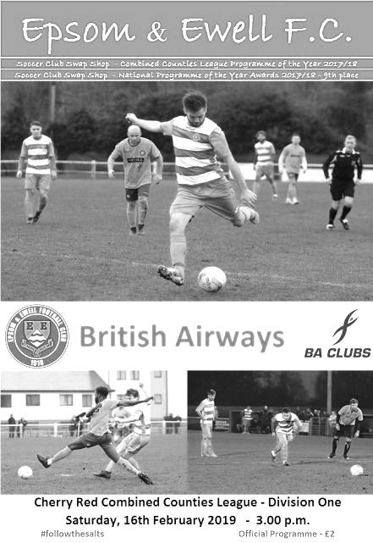
A much improved second half performance, capped by a pair of strikes from Bobby Bennett enabled us to turn a 2-1 deficit into a 3-2 win against British Airways at High Road on Saturday. Bearing in mind the opponents, it was somewhat ironic that our scorer had stepped off a plane just a couple of hours previously and in fact only made it to the ground at 2.20!

We made three changes from our midweek win over Godalming as both Luke Elgar and Reisse Griffin were unavailable, so Olly Martinez found himself pressed into service as an emergency left back, while Louis Chin returned at right back after being ineligible for the previous match, and up front Hakim Griffiths started in front of Rob Hendry who was on a school trip.

The majority of the early exchanges were in our favour, although Conor Young found himself fielding a couple of speculative efforts. We had our first shot on goal in the fourth minute when Griffiths was fouled just outside the area, but in a wide position. Adam Heagney's free kick found Billy Carney but he appeared to see the chance late and was only able to prod the ball goalwards where Perry Cheadle was able to make a comfortable save. Bennett was next to feature in the 13th minute when a crossfield ball was flicked on to him by Carney, but he drove his shot across goal and beyond the far post.

Ben Chick saw his dangerous cross headed away by a defender but we probably should have gone behind in the 17th minute when a free kick was flicked on into the path of Jordan Haynes, who hit the ball straight at the relieved Young from 12 yards. Then out of nowhere we had a scuffle in the middle of the park which resulted in yellow cards for Ryan Sullivan and Jeff Kalejaiye.

We took the lead in the 24th minute with a nice move. Scott Murphy, playing at centre half pinged the ball down the left wing where Chick found himself onside and in space. He cut in on goal, drawing the defender before cleverly pulling the ball back for Griffiths to drill first it time, low and just inside Cheadle's right hand post from twelve yards.

Bennett put his next cross just ahead of the incoming Carney before we were forced into a change when Chick hurt his hamstring and Liam Roberts took his place on the left. However, we were beginning to cruise a bit and a casual back pass from Lloyd Connelly was spooned up by Young to Haynes who tried his luck from 25 yards, forcing a straight forward save. There was a degree of sloppiness creeping into our game and although we nearly scored a second when Carney's low right wing cross hit a defender and diverted away from Roberts just a couple of yards out, we conceded an equaliser in the 35th minute when a ball in from the left was sent goalwards by Kalejaiye and deflected off Martinez before creeping in off Young's right hand post.

It was unfortunate to concede in this manner but the visitors had their tails up and then took the lead

four minutes later after Connelly's under hit back pass was intercepted and although Young held their man up for a while, the ball reached Jake Girt at the far post and he knocked the ball past the defender on the line from close range.

Before half time we tried to repair the damage although Griffiths was well wide with a shot while Carney saw his shot deflected directly to Bennett, but he was wide out and his attempt was on target but didn't trouble Cheadle. We were still making chances though and just had to raise our game a bit more as we finished the half looking very average, particularly in midfield.

There was clearly a frank exchange of views in the dressing room at half time and it appeared to fire our boys up with an equaliser coming as early as the 48th minute thanks to a defence splitting pass from Adam Heagney which was finished off into the bottom corner by Bennett. It must be said though that we had almost gone 3-1 down seconds before that when a Young punch had gone straight to a visiting attacker who had squared the ball to Kalejaiye who missed a great chance from just inside the box.

However, we were now in the ascendency and if any team was going to score, it looked likely to be us. Griffiths did really well to close down a defender who was waiting for his keeper to collect, and he got a toe to the ball between them but couldn't quite get the ball on target. Elliott Thompson then joined the fray for Sullivan who had a knock and we really started to take control. Daniel Callan sliced the ball over his own bar from a left wing cross, while Griffiths nearly got on the end of an enormous Young kick but couldn't quite keep the ball in play. As we entered the final twenty five minutes a Louis Chin cross was headed onto the crossbar by Griffiths but the loose ball fell to a defender who cleared the danger. We were really pushing for a winner now and further pressure forced a heavy back pass which Cheadle had to dive at full stretch to prevent going into his net.

In the 72nd minute we had two chances as Bennett fed Carney who set up Heagney whose shot was blocked but the danger wasn't cleared and Roberts then saw his low shot squirm through Cheadle, although he got enough of the ball and was able to lean back and fall on it before we could take advantage. Then in the 75th minute Griffiths did really well to chase down a lost cause in the corner and rob a defender before pulling the ball back to Heagney whose shot was powerful but just beyond the far post.

Time was running out if we were to make this five wins on the spin and it was Bennett who had the final word in the 79th minute. Running forward at the British Airways defence, a gap opened up and it looked as though he was going to go through himself but just as he did, defenders came over so he fed Carney on the right who unselfishly returned the ball to the by now unmarked Bennett who guided the ball into the far corner of the net from twelve yards for what would prove to be the winning goal. Murphy fired over the bar with a late free kick after Roberts had been fouled before Thompson gave Bennett the opportunity to finish the match in style, but with just Cheadle to beat he went for power and cleared the bar with his effort.

It would have been a fitting personal climax for Bennett, but in all honesty 3-2 was probably a fair result in the end. We had lost by the same score over at The Orchard in October which proved to be the final match in charge for our previous Manager Neil Grant, but this result and in particular the second half performance showed how far we have come in recent months as this unbeaten run of eleven matches is something we've only achieved eight times in club history and with the two top teams in the table dropping points, we closed the gap at the top of the table to just three points. However, to come away with any silverware this season we will have to play better than we did in this match, as it was for long periods a very scrappy and underwhelming performance, especially by comparison with our recent standards.

Epsom and Ewell: Conor Young, Louis Chin, Olly Martinez, Adam Heagney,
Lloyd Connelly, Ryan Sullivan, Bobby Bennett, Scott Murphy (c), Billy Carney,
Hakim Griffiths, Ben Chick

Subs: Liam Roberts for Chick (28), Elliott Thompson for Sullivan (57)

From behind the goal
Metropolitan Police U23 Academy 4-2 Epsom & Ewell - no programme produced
Surrey Premier Cup - Quarter Final - Wednesday 20th February 2019

Unbeaten run arrested at Imber Court

Our unbeaten eleven match run came to an end at the hands of the Met Police Academy in the Quarter-Finals of the Surrey Premier Cup at Imber Court on Wednesday night. Although the result was a fair one, there were a couple of key moments in the match and had they fallen in our favour, maybe we could have come away with something on the night.

There were three changes from our win over British Airways with Luke Elgar returning for the ineligible Louis Chin, while Ryan Sullivan was injured so Elliott Thompson played a full ninety minutes in his place and Liam Roberts came in for Ben Chick who was still nursing sore hamstrings after Saturday's match. With Reisse Griffin and Rob Hendry both still unavailable through illness and work respectively it has to be said that we were a little restricted in terms of options with Olly Martinez having to repeat his role at left back once again, despite having broken some fingers in the last few days.

On a decent playing surface on a perfect night for football we got off to a terrible start as Aiden Torpey met a left wing cross from close range to put the hosts ahead in just the third minute and six minutes later he added a second as he was put straight through by a nice pass and finished past the exposed Conor Young to make it 2-0.

We responded immediately as Hakim Griffiths showed great strength to hold off his defender before setting Billy Carney up to finish low under the advancing Alfie Rule from 12 yards to reduce the deficit in the tenth minute. The game continued to swing from end to end and Scott Murphy made an important block from a right wing cross before Torpey sent a header into Young's arms shortly afterwards. Both Griffiths and Adam Heagney had attempts on goal in the first quarter of an hour too.

Both sides looked likely to score from almost every attack, but our equaliser required a bit of fortune as Rule was adjudged to have conceded a corner by the Assistant. As the second nearest person to the incident after the keeper himself I can confirm that the ball didn't even touch the goal line and from the position the Assistant was in, the keeper was also blocking his view, yet he still felt it was a corner. You could sympathise with their man, although he then did himself no favours by belting the ball away in frustration, earning an unnecessary yellow card. Moments later he was picking the ball out of the net as Heagney's deep corner was headed back across goal by Lloyd Connelly where Bobby Bennett reached the ball first to poke it in from about a yard out in the 24th minute.

We were in the ascendency at this point, even if it was noted that Young was unable to take his goal kicks. Bennett's ball across goal was collected by Roberts who saw his shot on goal blocked, but the home side began to take a bit of control back as the half concluded and a couple of decent efforts went begging before they retook the lead with a solo goal by Ryan King, who has made first team appearances for the club this season. He ran in from a central position some distance out, nutmegging one of our

players, then beating another before dummying Young and leaving an easy finish for a quality goal in the 39th minute.

We fought back well in the closing minutes of the half. Heagney's swerving shot from twenty yards was palmed away by Rule and Roberts had a try from the left, sending a curling effort towards the far corner but Rule was there again to keep the ball out. The subsequent corner came to nothing and we went in at the half trailing, but by no means out of the match.

We came out for the second half in determined mood. Attacking the covered end Griffiths did really well to hold off his man but had a shot blocked. Then on the hour he set up Billy Carney whose great touch took him past a defender and he then walked the ball around the keeper. However, with just a defender on the line and the rest of the goal to aim at, he lashed the ball straight against Kiaro Applegarth's chest from just eight yards out and the ball was cleared. Had we made it 3-3 at this point, maybe we'd have gone on to win the tie.

We kept pushing though and a deep Elgar cross was nearly put into his own net at the far post by Applegarth, whose clearance ended up in the side netting instead and three minutes later his header was also blocked on the line by another defender. Taryn Smith came on for Roberts before we then had a goal disallowed after Elgar was adjudged to be marginally offside, before producing a striker's finish into the bottom corner. Our attacks continued and George Isaacs picked up a yellow card for a foul on Heagney on the edge of the box. Then Smith's dangerous cross was deflected out for a corner but it all went horribly wrong at this point as Heagney's delivery didn't clear the first man and from the counter attack Billy Brown received the ball and finished past Young in the 75th minute to make the score 4-2.

This was a little harsh on our boys and in response a deep delivery from substitute Sam Morgan came back off the frame of the Met Police goal, but in truth the closing minutes could have ended with more goals against us as we pushed forward, leaving us more exposed as a result. Young tipped one particularly good effort around the post while in the 89th minute Rule also made a fine save from Bennett's free kick wide out that he whipped around the wall and had sent arrowing towards the far corner.

The final action came as Murphy's deep cross from the left was inches too high for Connelly who was unable to direct his header on target as a result and ultimately that summed up the game. Nearly but not quite against a good team who may well go all the way in this competition. We wish them well in the Semi-Finals.

Epsom and Ewell: Conor Young, Luke Elgar, Olly Martinez, Adam Heagney, Lloyd Connelly, Elliott Thompson, Bobby Bennett, Scott Murphy (c),
Billy Carney, Hakim Griffiths, Liam Roberts

Subs: Taryn Smith for Roberts (64), Sam Morgan for Martinez (69),
Todd Murphy for Griffiths (80)

From behind the goal
Frimley Green 4-2 Epsom & Ewell
Combined Counties League - Division One - Saturday 23rd February 2019

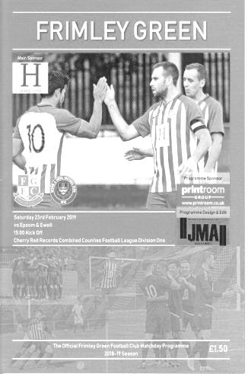
Salts scattered as Frimley take revenge

Back in November a very close looking encounter on paper took place at High Road with Epsom proving decisive winners by three clear goals that day. Three and a half months later the tables were most definitely turned as the hosts used their knowledge of the conditions at the Frimley Road Recreation Ground better that we did and thoroughly deserved their win on the day. In addition to providing revenge for their earlier loss, it carried an added benefit of providing Frimley's Management team of John Cook and Jamie Daltrey with some redemption for that memorable evening in August 2016 when they had been in charge of Bedfont & Feltham as we recovered a 2-0 half time deficit to win 9-2.

I must admit though, I didn't see this result coming. An unbeaten run of nine league matches since losing at Eversley & California had enabled our boys to close the gap on the leading clubs and we looked ready for the upcoming confrontations against the other top clubs, of which this was the first, whilst Frimley had been held at home by Godalming Town last weekend; a team we had decisively beaten four days previously, but, we were not allowed to get going as we were hassled, harried and largely bullied by a very committed Frimley Green team.

While at no point providing an excuse for this listless display, we were slightly affected by major withdrawals this week as regular keeper Conor Young had advised some time ago that he would be away this weekend, and Rob Hendry, Reisse Griffin and Ben Chick were working, while Ryan Sullivan remained on the injured list. In Young's place came Sheikh Ceesay, a keeper with Isthmian League experience and Jake Robinson, another player from the fringes of the Chipstead side that had provided us with Billy Carney. Both started, moving Liam Roberts to the bench, and we were further restricted when Olly Martinez was injured in the pre-match warm up and Luke Elgar came in at left back.

We started badly once again and for the second match in a row we were behind in just the third minute. A long ball pumped forward was allowed to bounce by Lloyd Connelly who then saw the Frimley player head the ball over him and into the path of Sean Latimer. Connelly tried hard to recover but Latimer kept his cool and drilled the ball past Ceesay from close range with no other covering defenders in the vicinity.

In response Hakim Griffiths hit the target from 25 yards but didn't trouble Chris Harris in the Frimley goal and neither did Robinson with a similar try minutes later. The home side were soon back on the attack again as Bobby Bennett gave the ball away and the left wing cross fizzed across our six yard box. Another pass was then given away in the 12th minute but Ceesay made a good save with his feet to block a shot from close range. Unfortunately, we then went further behind in the 17th minute when a harmless looking ball found Latimer just inside the penalty area. He was being marked, but turned away and then shot the ball back in; the ball going past, or maybe under Ceesay's left hand. Maybe our keeper should have done better with this, but it was disappointing that he was allowed to shoot in the first place.

Griffiths just cleared the bar from eighteen yards after receiving a square pass from Robinson, who showed promise in the first half, and we put together our first move of real danger in the 27th minute when a deep Elgar cross was volleyed back across goal at the far post by Bennett, requiring a Frimley defender to head the ball out for a corner with Robinson close to meeting the cross.

However, the corner came to nothing and we went 3-0 down in the 28th minute with what can only be called an unmitigated disaster of a goal, both from our point of view and the officials. Harris sent a long kick through and our defenders were nowhere near it, leaving Dan Bone through on goal. As Ceesay advanced, Bone swiped his hand at the ball which totally deceived Ceesay and the ball ran into the unguarded net. Our players were incensed about this as they were all convinced that there had been contact with Bone's hand. The Assistant was not up with play and neither he nor the referee saw anything of concern, but from watching our players’ reaction, and the video replay that is available on our Twitter site, thanks to a local ground hopper, it was clear there had been some sort of illegal contact. It nearly got worse too as Connelly was tricked by the winger and brought down just inside the area in the 37th minute. Connelly received a rather harsh booking for this as there was clearly no intent whatsoever, but we received a let off when Eddie McKinlay's penalty crashed off Ceesay's right hand post and away for a goal kick.

The half time talk, which was held outside, was uncompromising and the players were left in no doubt that they had to raise their game and compete better, but just as we looked ready to do that, Bone cut inside a defender and rifled the ball low inside Ceesay's near post from twenty yards in the 49th minute to make it 4-0. The second half was more even it must be said, but the hosts nearly made it five-nil as a lob was just tipped wide of the post by Ceesay. Although it was too little and far too late, the final twenty minutes were more in our favour and we had a couple of dangerous free kicks around the area that came to nothing before Louis Chin took a return pass from Bennett but fired straight at Harris.

In the 84th minute we pulled a goal back, maintaining our record of scoring in every league match this season as Ceesay's long kick was chased down by Roberts, who got there ahead of Harris to poke the ball past him and into the net. Three minutes later we had a second as Roberts chased another ball only to be bundled over with an unnecessary push and Bennett scored his tenth penalty of the season; a new club record. It has to be said that in amongst some extremely disappointing individual displays, Roberts was about the only player to enhance his reputation in this match However, time was obviously against us by this point and 4-2 was the final score.

Whilst credit should be given to the hosts who most definitely were more familiar with the bobbly pitch and adapted their style accordingly, this was also a most disappointing day at the office for our club. I could point to a couple of officiating decisions that didn't go our way but that would be hiding from the real reasons we lost and those who read my reports know that I will tell it like it is. We now find ourselves five points adrift of third placed Sheerwater, while being a further point away from both Frimley Green and Bedfont & Feltham and appear to have blown our chance of promotion with a forty-five minute display that was reminiscent of last year's disasters.

This is a real pity after the work that has gone in to the recent performances, although it is clear now that we have no choice but to win our remaining eight league matches if we are to stand any chance of promotion whatsoever. Based on what we saw at Frimley Green, we will have to improve substantially if we are to do that.

Epsom and Ewell: Sheikh Ceesay, Louis Chin, Luke Elgar, Adam Heagney,
Lloyd Connelly, Elliott Thompson, Bobby Bennett, Scott Murphy (c), Billy Carney, Hakim Griffiths, Jake Robinson

Subs: Liam Roberts for Thompson (54), Sam Morgan for Elgar (61)

This Day in History – 12th March
Date | Day | Competition |  | Opponents |  | Scorers
12/03/27 | Sat | Surrey Senior League | H | Farnham United Breweries | 6-3 | R.Marlow (3), F.Behn (2), F.Watts
12/03/32 | Sat | London League | H | Grays Athletic | 3-1 | R.Marlow (2), B.Williams
12/03/38 | Sat | London League | A | P.O.Engineers | 1-2 | J.Jones
12/03/55 | Sat | Corinthian Memorial Shield 2 | A | Uxbridge | 1-5 | G.Hurst
12/03/60 | Sat | Corinthian League | H | Erith & Belvedere | 3-3 | S.Law (2), N.Dearlove
12/03/66 | Sat | Athenian League 2 | A | Lewes | 4-4 | P.Scott (2), D.Hollands, A.Cox
12/03/77 | Sat | Athenian League 1 | A | Letchworth Garden City | 1-3 | T.Tuite
12/03/83 | Sat | Isthmian League 1 | H | Wembley | 0-0
12/03/85 | Tue | Isthmian League  Premier Division | H | Leytonstone/Ilford | 0-0
12/03/88 | Sat | Isthmian League 2s | H | Eastbourne United | 0-1
12/03/94 | Sat | Isthmian League 3 | A | Flackwell Heath | 2-2 | N.Webb, A.Nimmo
12/03/02 | Tue | Surrey Senior Cup QF | H | Crystal Palace | 1-3 | G.Morris (pen)
12/03/05 | Sat | Isthmian League 2 | H | Witham Town | 0-5
12/03/11 | Sat | Combined Counties Premier Division | A | Guildford City | 1-3 | A.Panayi
12/03/16 | Sat | Combined Counties Premier Division | H | Knaphill | 1-2 | J.Taylor
Historical Decades
90 years ago – Epsom Town F.C.
16/03/29 | Sat | London League | H | Carshalton Athletic | 6-0 | F.Behn (4), J.Parr (2)
80 years ago – Epsom F.C.
11/03/39 | Sat | London League | H | Uxbridge | 3-0 | T.Rochester (2), J.Jones (pen)
70 years ago – Epsom F.C.
19/03/49 | Sat | London League | H | R.N.Depot | 4-1 | F.Marshall (2), H.Watkins, N.Griffiths
60 years ago – Epsom F.C.
14/03/59 | Sat | Friendly | H | Clapton | 0-3
50 years ago – Epsom & Ewell F.C.
15/03/69 | Sat | Athenian League 2 | A | Marlow | 0-4
40 years ago – Epsom & Ewell F.C.
17/03/79 | Sat | Isthmian League 1 | A | Hertford Town | 0-1
30 years ago – Epsom & Ewell F.C.
11/03/89 | Sat | Isthmian League 2s | H | Harefield United | 1-0 | C.Hadingham
20 years ago – Epsom & Ewell F.C.
16/03/99 | Tue | Isthmian League 3 | A | Flackwell Heath | 6-1 | K.Webb (pen), J.Tome, S.Miller, A.Barton, A.Boxall, o.g.
10 years ago – Epsom & Ewell F.C.
17/03/09 | Tue | Combined Counties Premier Division | A | Cobham | 2-0 | R.Burns, K.Hough

History Corner – 12th March
We have an appalling record on this day! It is our eighth worst in history and although we won our first two matches on this date, we have not won since, going back to a 1932 win over Grays Athletic!

92 years ago today our main rivals for the Surrey Senior League title, Farnham United Breweries, visited West Street for an important League match. I say it was important, but in truth, everyone already knew that the title was heading back to West Street by then and we underlined this with a comprehensive 6-3 victory with Reg Marlow scoring three goals. He would end up with 65 this season, still comfortably a club record! Freddie Behn scored two goals while Fred Watts got the other one.

90 years ago this week we defeated Carshalton Athletic by six clear goals in a London League match at West Street with Freddie Behn scoring four goals from the right wing. Jack Parr scored the other two but we would not defend our League title that year, falling away to finish fifth of the thirteen teams. (see programme pictured)

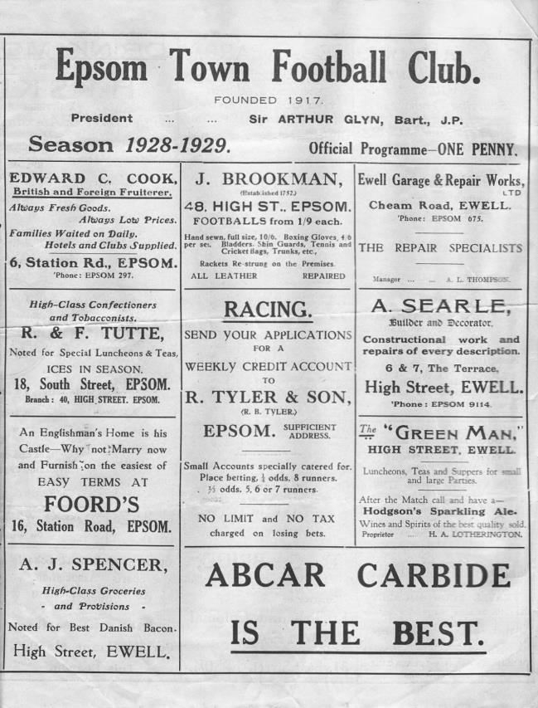
77 years ago today Reg Marlow scored twice and Billy Williams once as we defeated Grays Athletic 3-1 at West Street. We have not won a match on this day since then!

20 years ago this week we visited Flackwell Heath for a League match but had difficulties due to traffic and actually started with ten men. I recall Dave Wilson asking me if I’d brought my boots and I’d have definitely had a go if I had! Anyway, we were back up to the full eleven after a quarter of an hour and went on to destroy the opposition 6-1 with five different scorers and an own goal!

8 years ago this week some of us walked to Guildford City’s Spectrum ground from the Epsom Clock Tower to raise funds for the club and were rewarded with a dismal 3-1 defeat, although we did get to see young defender Anthony Panayi score his first goal for the club, so it wasn’t all bad, even if Ben Hayward’s red card put a bit of a downer on it!

Matchday!
On Wednesday 13th February I received a very unusual email from Jessica Ramsey at the advertising agency Cake Havas! It was to advise that we had been selected from a list of local clubs to take part in a photo shoot for a new Football Association App in conjunction with Paypal UK called Matchday!

The official launch was happening two weeks later and they would require about a dozen of our players and of course, a ground to shoot the footage at. Also present would be former England Internationals Lee Dixon and Rachel Yankey; obviously a huge selling point for our players, particularly those with Arsenal leanings!

There was only one slight issue which was that the shoot was to take place just seven days later on the following Wednesday, 20th February! I advised Jessica that we didn’t actually have our own ground and that we’d have to run it past Chipstead first, as well as with Simon Funnell to ensure that we could actually get enough players to take part, as it would require a full day off for most of them. He also brought in former players Ben Dyson and Germaine Jeannoel to help. As the day of the shoot approached, a number of messages between all the above parties and Chairman Pete Beddoe ensued as we tried to confirm before the weekend that we could meet the requirements. It was a close call but we got there!

On the day itself, I arrived at 10.30, only to find Jessica already there and ready to greet people. She was very keen! As the players and our Management team began to arrive it

Pete Beddoe (left) watches proceedings in the clubhouse as the first briefings started

was apparent that this was a really big deal. There must have been over thirty people there connected with the agency; social media teams, organisers and assistants, film crews and yes, models too, both male and female and all dressed up in Paypal kit! A couple of early meetings took place and then off they all went. Fortunately it was a

lovely sunny day, which made the whole thing a more pleasant experience for all as there would be a fair bit of waiting around over the course of the day.

Our players were asked to get changed at about 11.15 and they did a bit of shooting at the clubhouse end while people filmed them. I don’t think any of the shooting made it onto the app footage, so it probably wasn’t very good

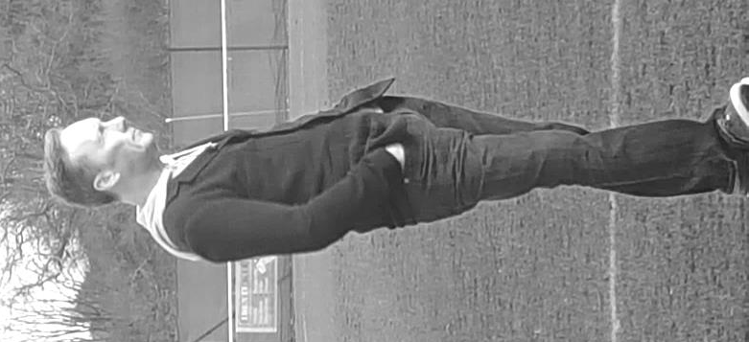
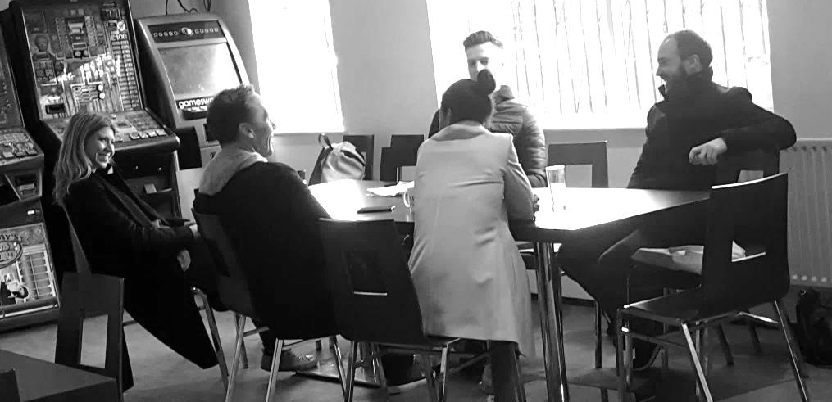
The players then got together and did a few training exercises during which Lee Dixon arrived. He was a little smaller than I expected, as he was around my height, but was a really nice guy, asking many questions about our club and taking a real interest. Rachel arrived soon after and the pair of them then received their own briefing on what was expected of them. (see both pictures)

There was so much going on and so many people doing many different jobs, but it was hard to work out whether they were on schedule or not. I was assured everything was going well and so I left them to it! The players seemed to be enjoying the whole experience, including regular supporter George Drew, 14 year old son of our Coach Matt, who had been drafted in to join the other players.

There was a bit of a break for lunch and the agency brought lots of food and drinks in, while our players, somewhat worryingly, preferred to raid the burger bar, all at the Agency’s expense. I won’t reveal who had what to eat. but the majority were sensible bearing in mind that

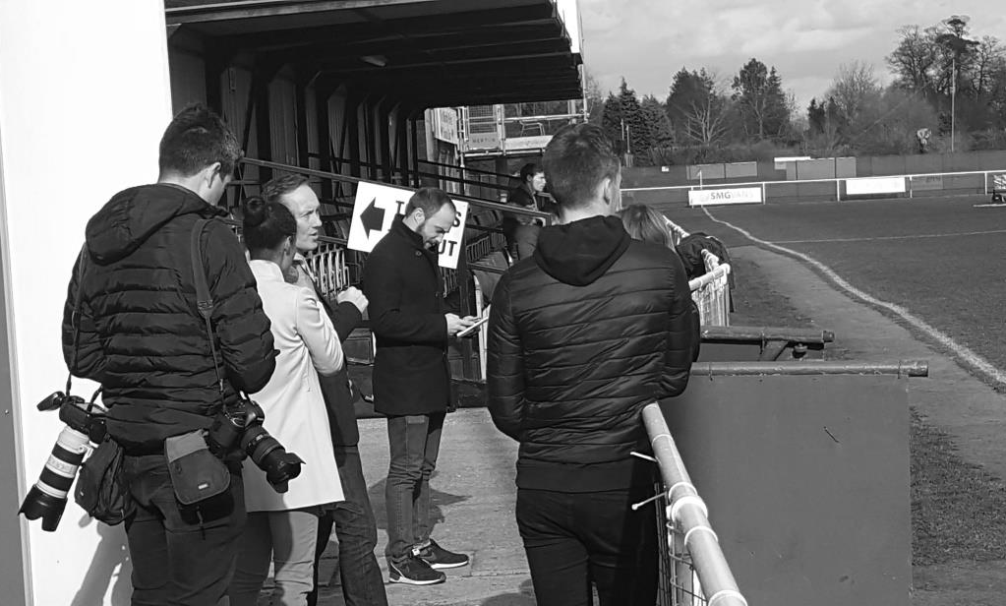

One of the film crews show Lee Dixon and Rachel Yankey the sights of Chipstead!

we had a big match against Met Police that evening!

Then some of our players and Management were called in for interviews, as was Pete and of course Lee and Rachel. It’s hard to believe that all of this work was required just
The Paypal models line up with Jessica Ramsey to the left of the picture

to produce a 30 second film to promote the app, although with the National Press launch there were to be a few pictures too, which some of you may have seen on Sky Sports or the BBC website. The links will be available on our website shortly for those who haven’t seen them yet.

Although the footage, subsequent meetings and de-briefings took around six hours in total, the day seemed to fly by. There was time for the players to all receive individual pictures with Lee and Rachel before the players were released at around 4pm as were our celebrities. Before I knew it, the time was nearly 6pm and I was leaving for our evening match myself. We then had to wait for seven days before the footage all went live on Wednesday 2nd March. We had been forbidden from advertising the event due to an advertising embargo, but the photos are now available on our website.

So our football club are now known as the face of the Matchday App and Captain Scott Murphy even had his fifteen minutes of fame by getting a name check on the Sky Sports article! All that remains is to thank everyone involved in making the day a special one to remember for our club. Firstly to our players, for taking their time off to be available at such short notice, to Chipstead FC for the use of their pitch, to Simon, Matt, Paul and Pete for the organisation of the pitch and players and of course to Jessica herself and her colleague Nick Gabriel for approaching us in the first place.

It was a glimpse through a window to a world we are not very familiar with and it was exciting to be a part of it, even if just for a day!

Lee and Rachel get the boys to wave to the cameras!

Above and Below
Surrey Elite League Table
incl Saturday 9th March | P | W | D | L | F | A | Pts | GD
AFC Cubo | 24 | 15 | 4 | 5 | 67 | 32 | 49 | +35
Westside | 23 | 14 | 6 | 3 | 55 | 25 | 48 | +30
Battersea Ironsides | 21 | 13 | 4 | 4 | 66 | 33 | 43 | +33
Chessington KC | 21 | 13 | 3 | 5 | 58 | 39 | 42 | +19
Spartans Youth | 21 | 12 | 5 | 4 | 50 | 30 | 41 | +20
Merrow | 20 | 11 | 4 | 5 | 51 | 34 | 37 | +17
Royal Holloway Old Boys | 21 | 9 | 4 | 8 | 48 | 33 | 31 | +15
Staines Lammas | 19 | 9 | 3 | 7 | 46 | 27 | 30 | +19
Horsley | 20 | 9 | 2 | 9 | 59 | 51 | 29 | +8
NPL | 21 | 6 | 7 | 8 | 44 | 43 | 25 | +1
Farleigh Rovers | 23 | 7 | 1 | 15 | 35 | 64 | 22 | -29
Worcester Park | 22 | 5 | 5 | 12 | 36 | 57 | 20 | -21
AFC Spelthorne Sports | 24 | 4 | 7 | 13 | 34 | 58 | 19 | -24
Ripley Village | 22 | 2 | 5 | 15 | 29 | 82 | 11 | -53
West End Village | 22 | 2 | 2 | 18 | 30 | 100 | 8 | -70
Godalming & Farncombe | Resigned after one match
When we last looked at this division, I advised that two teams are scheduled to be relegated from our division with the Surrey Elite and the Middlesex County League being the recipients. However, we started the season one team short and then lost AC London so I don’t believe any will go down. Having said that, the FA promise to relegate the bottom club in the five steps above, regardless of spaces or reprieves, so we could still lose one and get three in. We hear that Jersey Bulls will be joining us almost certainly next season, as could Bracknell Town Reserves, although they are arguably not in the Combined Counties catchment area any more.

But who will come up from the Surrey Elite League? One thing that is clear is that it won’t be any of the three relegated clubs from last season, Worcester Park, Farleigh Rovers and Staines Lammas. It is of course very unlikely that we will see any of these clubs back in at Step Six in the future anyway without serious upgrades to their grounds, especially as the FA have recently confirmed that we will get an extra Step Six league this year but then bizarrely drop back to just 16 for season 2020/21! Many clubs are due to earn promotion next season to fill the new Step Four League and two Step Five Leagues, hence the need for less Step Six divisions and I believe that four or maybe five even could be promoted from our division at the end of next season.

Anyway, back to the League itself where it’s tight at the top. All six of the top clubs could still win the title, but even if they do, the clubs must have Step Six facilities to be promoted, I originally thought it would be Westside, a Christian faith club that currently shares with AFC Croydon Athletic, but Croydon is very much an area covered by the Southern Counties East League so they may end up there instead. I am still not sure whether the Barn Elms Sports Centre in Barnes currently has the facilities for Step Six football so league leaders AFC Cubo may have to wait a little longer, but I could be wrong!

Combined Counties League - Premier Division Table
incl Saturday 9th March | P | W | D | L | F | A | Pts | GD
Sutton Common Rovers | 31 | 20 | 6 | 5 | 70 | 39 | 66 | +31
Chertsey Town | 26 | 20 | 5 | 1 | 68 | 26 | 65 | +42
Abbey Rangers | 29 | 16 | 3 | 10 | 50 | 49 | 51 | +1
Guildford City | 30 | 15 | 4 | 11 | 52 | 50 | 49 | +2
Southall (-1) | 31 | 14 | 7 | 10 | 52 | 35 | 48 | +17
Banstead Athletic | 31 | 11 | 13 | 7 | 46 | 35 | 46 | +11
Spelthorne Sports | 31 | 13 | 5 | 13 | 55 | 40 | 44 | +15
Raynes Park Vale | 30 | 12 | 8 | 10 | 38 | 43 | 44 | -5
Redhill | 30 | 12 | 6 | 12 | 55 | 53 | 42 | +2
Horley Town (-1) | 31 | 12 | 7 | 12 | 52 | 54 | 42 | -2
Badshot Lea | 29 | 12 | 4 | 13 | 41 | 55 | 40 | -14
Camberley Town (-3) | 31 | 12 | 5 | 14 | 53 | 54 | 38 | -1
Colliers Wood United | 31 | 11 | 5 | 15 | 53 | 57 | 38 | -4
Knaphill | 30 | 11 | 4 | 15 | 41 | 58 | 37 | -17
Cobham | 31 | 9 | 7 | 15 | 49 | 53 | 34 | -4
AFC Hayes | 30 | 9 | 6 | 15 | 40 | 47 | 33 | -7
Hanworth Villa | 30 | 9 | 5 | 16 | 32 | 53 | 32 | -21
Balham | 29 | 9 | 4 | 16 | 39 | 48 | 31 | -9
Walton & Hersham | 31 | 7 | 8 | 16 | 49 | 74 | 29 | -25
CB Hounslow United (-3) | 30 | 9 | 4 | 17 | 43 | 55 | 28 | -12
Here is the latest state of play in the division above us. The story of the season has been Chertsey Town, who are in with a chance of becoming only the second club from this league by reaching Wembley in the Final of the FA Vase if they can defeat Northwich Victoria in the Semi-Finals coming up over the next two weekends. I should point out that the other club to achieve this was Epsom & Ewell in 1975!

In the meantime, Sutton Common Rovers have got many League matches played as they attempt to set a target that a tiring Chertsey may not be able to overhaul. However, with only one club going up, it looks like SCR will miss out narrowly once again as things stand.

We had first-hand experience of third placed Abbey Rangers recently and it looks like third is as high as they will reach this term. None of those three clubs surprise me by being up there, although more relevantly for us now, it is a question of who will join us down in Step Six next season. Right now it could be any two of the bottom six, but technically anyone up to and including Camberley Town, currently ninth from bottom, could get dragged in here.

I am however surprised to see the current bottom two down there. Walton & Hersham and CB Hounslow United should both be building momentum in their new grounds, and should really be established this season, yet find themselves in serious trouble. It is a cautionary tale that there are no guarantees any more, not even with a new ground.

Centre page for results

Centre page for results

Match and Ball Sponsorships – 2018/19
Opponent | Date | Match Sponsor | Ball Sponsor
Chessington & Hook Utd | 21/08/18 | Club President - Stella Lamont
Beckenham Town (FAC) | 28/08/18 | Building Shop Ltd
Cove | 08/09/18 | EEFC Management Committee
Tooting Bec | 15/09/18 | Building Shop Ltd
Bagshot (LC) | 25/09/18
Sheerwater | 06/10/18 | Paul Merritt
Knaphill U23  (Surrey Premier Cup) | 23/10/18 | Jack Jarman
Frimley Green | 03/11/18 | Our Chairman’s Grandchildren – George, Joseph, Ezara and Inaya
Sandhurst Town (LD1C) | 06/11/18 | Richard Lambert
Kensington Borough | 17/11/18 | Jeff & Arnold Pye
Dorkinian (SPC) | 20/11/18
Dorking Wanderers Res | 27/11/18
Godalming Town | 01/12/18 | John Bonner
Bedfont & Feltham | 08/12/18
Eversley & California | 29/12/18
Ash United | 12/01/19 | Gary and Gemma Jarman
Bagshot | 19/01/19 | Steve and Geoff Dyke
Godalming Town (LC) | 12/02/19
British Airways | 16/02/19 | Pete Lumm
British Airways | 16/02/19 | Stephen Charnley
FC Deportivo Galicia | 12/03/19 | Alex McKay (senior)
Fleet Spurs | 06/04/19
Sandhurst Town | 20/04/19 | Club President - Stella Lamont
Farnham Town | 27/04/19 | In memory of Chris Henry R.I.P.
Match sponsorship costs just £60.00!

Sponsorship includes:

Admission, programmes and hospitality for three people.

A full page advert in the programme and mascot for the day (if required).

If you are interested, just speak to a Committee Member,
or drop me an email at: richard.c.lambert@gmail.com

Previous Managers
In our latest instalment we look at a very worrying period in our history.

Barry Barnes – 08/04/2003 – May 2004
Ray Purvis – May 2004 – 21/01/2006
Paul Pritchard – 21/01/2006 – 26/08/2006
Peter Augustine (caretaker) – 26/08/2006 – 28/10/2006

Ada Hill’s retirement left a huge gap to fill. On the face of it, the decision to appoint Barry Barnes as Manager was fairly straight forward. He had been a successful Coach for the club in the recent years following the retirement of Ada’s right hand man, John Wood, and bringing in former long serving player Micky Stratford as the new Coach made a lot of sense, in theory.

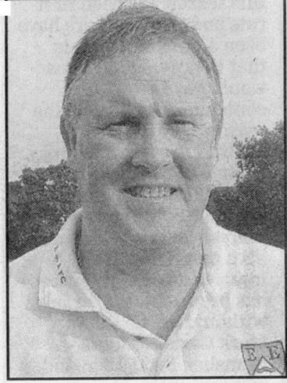
In practice, it just didn’t work out, but it wasn’t all their fault. In the summer of 2003 several of our players left the club to join Croydon Athletic including our top players James Hall, Adrian Toppin and Barry Stevens. Hall surprisingly would not progress, although Stevens would go on to make many appearances for Carshalton Athletic and Toppin would go on to play for Staines Town when they reached the Second Round of the F.A. Cup in 2007, defeating Stockport County on penalties, although he scored the goal that originally put them ahead in the tie.

For our club, a tough season got even tougher from this point and although we defeated Corinthian Casuals 1-0 in our second match of the season at King George’s Fields, we would not win another match until February after setting a club record thirty matches without a win, including a run of seventeen defeats, which would have been another record had we not had a 1-1 draw with Worthing in the middle of the sequence. Then we received the news that solid defender Mark Freeborough would have to quit the game after he was diagnosed with a brain tumour, although thankfully he was able to recover from this.

By now Stratford had departed and he too would go on to greater things as Assistant to Mick Sullivan in the all-conquering Merstham team of 2007/08. He was replaced by another former player Ray Purvis, who had been running our Reserves to that point. Then we suffered a 0-8 defeat at Walton & Hersham which was our worst defeat since 1968. Even luck was against us as we secured a 3-3 draw at Egham Town in the Surrey Senior Cup, only to lose a bizarre match 15-14 on penalties! Soon after this we lost another player as young striker Joel Rogers chose to retire!

There was a slight improvement in the New Year with narrow defeats to Tooting & Mitcham United after leading for quite a while and then a late equaliser from Met Police after a goal from stand out young striker Craig Watkins. Finally we won again in February on a windy night at Merland Rise with Corinthian Casuals again providing the opposition and we followed this with a 2-0 win at Croydon in February with what would prove to be the final goal from our record appearance holder Graham Morris. Then we defeated Molesey 2-0 and followed it up with a 2-1 win at Leatherhead but the bubble burst at Marlow and we lost seven of our eight remaining matches, picking up just a point against Banstead Athletic and being relegated by a point from Corinthian Casuals. Barry resigned, originally to go back to the Coaching position, although it didn’t work out like that and Purvis took over the reins with Freeborough as an Assistant, although another former player Paul Pritchard would also join in this role.

Purvis decided that he wanted to concentrate on Youth development, which was probably not his preferred choice, but was forced on him by factors such as the retirement of long serving players Graham Morris and Dave Hyatt who had over 1,000 appearances between them. Hyatt would play briefly elsewhere but not for long while Morris stopped completely. We also lost Watkins to Sutton United. We were also marking 11 years without a ground and had by now sold the site we owned at Banstead Road, leaving us in a position that remains unchanged to this day, so finances would have been tight back then too.

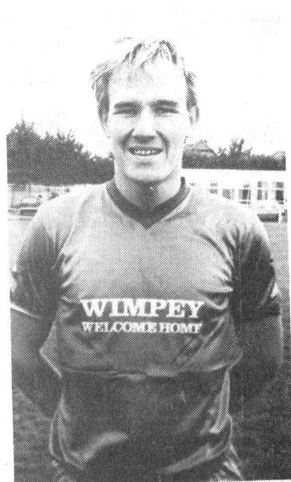
Still, he started well, and two wins and a draw placed us at the top of the fledgling Isthmian League Division Two table at the end of August. However, we wouldn’t play another League match until the 9th October due to it only being a 16 team league. Instead we had to play a number of matches in an Associate Members Trophy which placed us in a four team group with our “most local” opponents, Chertsey Town, Camberley Town and Brook House! Needless to say, it didn’t go well, with the “highlight” being a sponsored walk to Chertsey Town in September of 2004 which raised a bit of money for the club and MenCap but resulted in a pitiful display, losing 2-0 at Alwyns Lane.

There were occasional highlights, like a 5-2 win at league leaders Hertford Town, but even this triumph was followed by disaster in a 5-0 home defeat to Witham Town a week later. By season’s end we were third from bottom of the table, albeit well clear of Kingsbury Town and Clapton below us.

The following season would bring no similar respite as we found ourselves second from bottom with Clapton five points below us and that was because they had five points deducted!

By this time however, Purvis was gone. Sacked, following a 4-2 win over Chertsey Town in the January of 2006, largely due to what the club described unofficially as “unethical” procedures. Although I do not have chapter and verse on this and maybe our Chairman at the time Pete Lumm could shed further light on this, it appears as though the new Assistant, former keeper Tony Webb had been approaching a number of players at other clubs in an attempt to strengthen the squad. Purvis got the blame for this as he had appointed Webb, although it’s likely that this wouldn’t have happened had results been better! Paul Pritchard (pictured left as a Youth team player in 1979) was appointed as Caretaker Manager with Peter Augustine retaining his position as Coach.

It wasn’t a happy time though and a 3-4 loss to ten man Dorking on Easter Monday in a match we had led 2-0 at the point of the sending off summed up our plight. He started the new season, by now in the Combined Counties League, but a poor start culminated in a 6-1 home defeat to Egham Town and Pritchard was gone by the end of August 2006. Augustine remained as Caretaker Manager while the club interviewed for the position and would go once again in the direction of a former Epsom and Ewell player.

From behind the goal
Abbey Rangers 3-1 Epsom & Ewell
Combined Counties League Cup – Quarter Final - Tuesday 5th March 2019

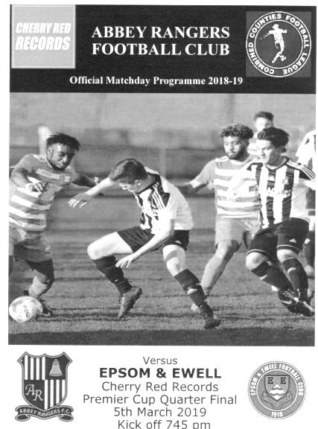
Abbey show class in second half

For the first 45 minutes of this match it was impossible to tell which of these two teams were playing in the higher division, but in the second half, Abbey Rangers stepped up a gear and won the contest in that fifteen minute spell, leaving us with nothing but memories of a cup run that has now ended.

This League Cup Quarter-Final was always going to be a difficult task for our boys. Two home wins over Step Six opposition had enabled us to reach this stage, while they had defeated local rivals and FA Vase Semi-Finalists Chertsey Town on their own patch. We went into this match on the back of our disappointing display at Frimley Green ten days previously and one of the big questions going into this match was whether this performance would be more spirited. I can report that it was.

It probably helped that Conor Young was back between the posts, although we never seem able to keep the same back four together, and this week had to deal with Luke Elgar's injury and Louis Chin's ineligibility. Although Reisse Griffin returned at left back with Adam Heagney in his original position of right back, we missed the latter's presence in midfield, particularly in the second half. Up front we were unchanged apart from Liam Roberts reclaiming his place in the starting eleven with Jake Robinson taking Heagney's place in midfield. Rob Hendry was only ever going to be a game time arrival, so could not start, but he would enter the fray later to good effect. Finally, there was originally going to be one more change as Ryan Sullivan was declared fit to reclaim his place, although he again broke down in the warm up, so Elliott Thompson continued in midfield.

Against a team containing many regular names from our last encounter thirteen months previously, the opening stages of the contest were even. On the wide open spaces of the Abbey pitch the teams passed the ball around, but neither really hurt the opposition with one exception, in the eighth minute when a pinpoint right footed cross from the left was almost perfect for Billy Carney to get his head to. However, he had to stretch a little and his header from eight yards out was just too close to Liam Stone, who was able to parry the ball to safety.

In response the hosts sent a couple of dangerous balls across the face of our goal but Young was having a fairly quiet night so far. We nearly scored in the 23rd minute when Liam Roberts tricked his man on the outside and cut in from the left, but Stone blocked his shot

up into the air, falling just behind new boy Jake Robinson who was unable to turn and get a proper connection on the ball.

Scott Murphy was next to make an important intervention when he headed a dangerous cross out for a corner. The subsequent delivery wasn't dealt with though and a low shot came in was cleared off the line to safety by an Epsom defender. Abbey followed this up with a deep free kick that was met by a glancing header just wide of Young's left hand post and we then had another opportunity of our own in the 40th minute when a Bobby Bennett low cross from the right was miscontrolled by a defender and Roberts intercepted it, but his shot was blocked and Carney fired the loose ball over the bar.

As the half ended we received another warning as Young had to make a good low save with his feet from a shot inside the box and it had to be admitted that they had finished the half, slightly stronger of the two teams, even if we had created the better chances. However, as with recent weeks, we weren't taking them and this time it would come back to hurt us.

It's hard to know whether the home side were told to step up their game in the half time team talk, but in the opening fifteen minutes of the second half we were hardly able to get out of our half. This led directly to their opening goal in the 53rd minute as we lost the ball in a dangerous area and it was fed through to Harrison Deacon who poked the ball past Young from ten yards. They nearly extended the lead two minutes later but Young made a good save, although there was nothing he could do about the second goal in the 57th minute. They were causing us trouble on the right wing and a low cross came over to Ben Kersley who appeared to have a tap in at the far post, but miscontrolled the ball. However, he had the presence of mind to recover and lay the ball back to Luke Robertson who then curled the ball over Young into the top corner of the net from twenty yards.

In the 65th minute it was three-nil as another right wing delivery left Liam Collins with a far post tap in that this time was accepted and the game was over. We reduced the arrears in the 67th minute after substitute Hendry belted one in with the outside of his left foot from 25 yards; the ball fading in slightly with the curl on the shot and going in off Stone's left hand post. Could we get back into this? Regrettably not. The game broke up a little from this point and apart from a rather harsh award of a free kick against Bennett for a back pass, which resulted in a shot blocked by Young and / or his wall, as is so often the case in those circumstances, the game petered out and ended 3-1 to the home side who now qualify for the Semi-Finals of the competition and must have as good a chance as anyone of winning it.

For us, making another appearance in the final; our third in six years and just two years after the last one was always a tough ask for our boys, but they showed enough to give the impression that we could survive back in Step Five, should the opportunity arise. It is imperative that we keep going in the league matches that remain, and of course the Division One Cup and let's see what we can achieve.

Epsom and Ewell: Conor Young, Adam Heagney, Reisse Griffin,
Elliott Thompson, Lloyd Connelly, Jake Robinson, Bobby Bennett,
Scott Murphy (c), Billy Carney, Hakim Griffiths, Liam Roberts

Subs: Rob Hendry for Thompson (60), Ben Chick for Roberts (72)

From behind the goal
Kensington Borough 5-1 Epsom & Ewell - no programme produced
Combined Counties League – Division One - Saturday 9th March 2019

Salts embarrassed at Fetcham Grove

A first half of quite horrific proportions occurred at Fetcham Grove on Saturday against relegation threatened Kensington Borough, who out-thought, out-fought and generally outplayed an Epsom side that until recently had been right in the midst of the promotion battle. Five goals were conceded in that period, leaving us with no chance of recovery, although we did manage to pull a goal back in the second half.

Statistically, with our opponents placed in the bottom three of the table, they were the lowest ranked club that we had lost to since 1923!

There were some extenuating circumstances. Simon was missing a number of players from our recognised first eleven. Reisse Griffin, Luke Elgar, Hakim Griffiths, Rob Hendry, Elliott Thompson, Ryan Sullivan and Liam Roberts were all unavailable for one reason or another and we had only been playing for eight minutes when Jake Robinson was harshly sent off, allegedly for denying a goal scoring opportunity when he got tangled up with a Kensington striker. There is no denying it was a foul, or that he was the last man back, but the foul occurred thirty yards from goal, with the striker running across the pitch instead of right at goal, and the contact was clearly accidental, yet we were down to ten men and completely up against it before we had even got going.

Things then got worse in a hurry as jet-heeled Waled Hirsi was put through on the left and he drilled his shot past Conor Young in the 18th minute. We nearly equalised after a good move involving Scott Murphy, Adam Heagney and Bobby Bennett which finished with a return pass from Bennett to Murphy who clipped his shot inches beyond the far post from twelve yards. Within a minute we paid for this miss when Hirsi got down the right, supplying a low cross that 18 year old debutant player Bilal Behi reached ahead of a defender and his first time strike placed the ball beyond Young from close range in the 28th minute.

Hirsi then caused more trouble down the right, finding himself in space and although Sam Morgan managed to get back to half block the cross, the ball wasn't cleared and the loose ball was bundled in, somewhat fortuitously by Abdirazak Dahir in the 31st minute to make it 3-0. Behi then missed another good chance as our defence went completely missing but in the 38th minute the hosts had a fourth goal when a simple pass was played inside our defensive line and Hirsi just ran onto it and got there ahead of the exposed Young to roll the ball into the empty net. Two minutes later the worst goal of the day came along when Murphy and Louis Chin both left a ball to each other, only for Dahir to run onto it, and place

a pass into the path of Hirsi who did the rest with a low finish.

This was the first time since the dark days of last season that we had conceded five goals in the first half and like with those previous occasions against Redhill and Chertsey Town last season, you really feared for the score in the second half. Once again the half time team talk was uncompromising and obviously unprintable!

The second half recovery could never be possible. All that our guys could do was to try and restore some pride with a second half performance unrecognisable from the first half and despite having just ten men, we were the better side in that period, reducing the lead in the 67th minute with a fine goal from our best performer on the day, Ben Chick, who chased a crossfield ball from Murphy, beat his man to it and then eluded a defender before crashing home a low shot into the Kensington net, which at least maintained our record of scoring in every league match this season, although it was a tiny consolation.

I could point to the early pivotal decision to send Robinson off, or even a number of other erratic calls, or non-calls by the referee, not to mention the inability to add hardly any time at the end of either half, despite injuries and scuffles that wasted time, but sometimes you have to hold your hands up and say that this one wasn't down to the officials. We have only ourselves to blame for this and can't look elsewhere for an excuse. Every single player that started this match needs to give serious thought to what they could have done better in front of a crowd of spectators that were exclusively Epsom fans, all of which were extremely embarrassed by the end of proceedings.

There were some positive performances from the substitute full backs George Brown and Chris Head, both making their debuts, while a third in Sam Eastgate came on towards the end, but this was a day with little good news as our club hit a new low. What is most worrying for me is that with ten men in the second half we made our opponents look fairly ordinary with Young having very little to do in that time, which tells me that we could and really should have done so much better in the opening forty-five minutes. Ultimately this will be remembered as one of those yardsticks over the next few decades when spectators witness a poor performance. "Yeah it was bad, but it wasn't as bad as that first half at Kensington Borough in 2019". I hope we never see its like again.

Epsom and Ewell: Conor Young, Todd Murphy, Sam Morgan, Adam Heagney,
Lloyd Connelly, Jake Robinson, Louis Chin, Scott Murphy (c), Billy Carney,
Bobby Bennett, Ben Chick

Subs: George Brown for Murphy (49), Chris Head for Morgan (49),
Sam Eastgate for Chick (81)

How we stand – Locally and Nationally – inc Sat 09/03/19
Here is the latest update on where we all stand.

To summarise for new readers, there are 28 promotion places currently available at Step Six, with 358 teams battling away for those spots. The Champions of each League are guaranteed a promotion, with the best nine runners-up also going up. This number looks as though it will rise by four due to no likely promotions from the South West Peninsula League and the now confirmed folding of Isthmian League Thamesmead Town and voluntary demotion of Aylesbury FC, but this could increase further. For now we’ll continue to look at the 28 and anything else will be a bonus!

In our previous review, we were listed as 69th Nationally. Since that update we have beaten British Airways, but lost to Frimley Green and Kensington Borough, so have moved down to 86th place.

Below is our current League table sorted by points per game, while across the page we have the overall top ten and most importantly the 28 clubs who would go up if the season ended right now.

Bedfont & Feltham are now holding the runners-up spot in our League on points per game and have the 13th best record of the 19 second placed teams. Our league is so competitive right now that it may well prove to be just the Champions that go up, but I’ll keep updating the position here while we remain involved.

Combined Counties League Division One Table – by PPG
 | Pld | W | D | L | Pts | GD | PPG | Pos
Frimley Green | 28 | 19 | 6 | 3 | 63 | +29 | 2.25 | 1
Bedfont & Feltham | 27 | 18 | 6 | 3 | 60 | +56 | 2.22 | 3
Sheerwater | 29 | 19 | 5 | 5 | 62 | +40 | 2.14 | 2
Farnham Town | 27 | 16 | 5 | 6 | 53 | +27 | 1.96 | 4
Epsom & Ewell | 27 | 16 | 3 | 8 | 51 | +19 | 1.89 | 5
Tooting Bec | 26 | 14 | 7 | 5 | 49 | +28 | 1.88 | 6
Sandhurst Town | 25 | 13 | 4 | 8 | 43 | +2 | 1.72 | 8
Ash United | 28 | 13 | 6 | 9 | 45 | +10 | 1.61 | 7
Chessington & Hook Utd | 27 | 11 | 6 | 10 | 39 | +2 | 1.44 | 9
British Airways | 28 | 11 | 4 | 13 | 37 | -6 | 1.32 | 11
Dorking Wanderers Res | 30 | 11 | 5 | 14 | 38 | -13 | 1.27 | 10
Bagshot | 30 | 10 | 4 | 16 | 34 | -44 | 1.13 | 12
Godalming Town | 29 | 9 | 4 | 16 | 31 | -27 | 1.07 | 13
FC Deportivo Galicia | 27 | 7 | 3 | 17 | 24 | -10 | 0.89 | 14
Kensington Borough | 27 | 5 | 8 | 14 | 23 | -27 | 0.85 | 15
Eversley & California | 27 | 6 | 2 | 19 | 20 | -22 | 0.74 | 16
Cove | 29 | 5 | 4 | 20 | 19 | -27 | 0.66 | 17
Fleet Spurs | 29 | 5 | 2 | 22 | 17 | -37 | 0.59 | 18

Step Six Table – by PPG – Top 10
 | Which League? | Pld | Pts | GD | PPG | Current Pos.
Harefield United | SSML | 29 | 83 | 68 | 2.86 | 1
Cheltenham Saracens | HellW | 14 | 36 | 51 | 2.57 | 2
Heather St Johns | Midland | 29 | 74 | 81 | 2.55 | 1
Selston | E.Mids | 29 | 73 | 66 | 2.52 | 1
Longridge Town | NWCN | 31 | 78 | 88 | 2.52 | 1
Amesbury Town | Wess | 28 | 70 | 50 | 2.50 | 1
Anstey Nomads | UCL | 29 | 72 | 76 | 2.48 | 1
Cheddar | Western | 28 | 69 | 51 | 2.46 | 1
Alfold | Scomb | 26 | 64 | 46 | 2.46 | 1
Steyning Town | Scomb | 26 | 64 | 43 | 2.46 | 2
Epsom & Ewell | We are 86th | 24 | 48 | +24 | 2.00 | 5

Step Six Table – The 28 Promoted Clubs if the season ended today
The 19 Champions – Based on current PPG
 | Which League? | Pld | Pts | GD | PPG | Current Pos.
Harefield United | SSML | 29 | 83 | +68 | 2.86 | 1
Cheltenham Saracens | HellW | 14 | 36 | +51 | 2.57 | 2
Heather St Johns | Midland | 29 | 74 | +81 | 2.55 | 1
Selston | E.Mids | 29 | 73 | +66 | 2.52 | 1
Longridge Town | NWCN | 31 | 78 | +88 | 2.52 | 1
Amesbury Town | Wess | 28 | 70 | +50 | 2.50 | 1
Anstey Nomads | UCL | 29 | 72 | +76 | 2.48 | 1
Cheddar | Western | 28 | 69 | +51 | 2.46 | 1
Alfold | Scomb | 26 | 64 | +46 | 2.46 | 1
Exmouth Town | SWP | 30 | 73 | +54 | 2.43 | 1
Haughmond | W.Mids | 30 | 71 | +74 | 2.37 | 2
Billingham Town | Northern | 32 | 75 | +54 | 2.34 | 1
Hashtag United | EastS | 30 | 70 | +48 | 2.33 | 1
Erith & Belvedere | SCEFL | 23 | 53 | +43 | 2.30 | 2
Burnham | HellE | 21 | 48 | +50 | 2.29 | 1
Frimley Green | CCL | 28 | 63 | +29 | 2.25 | 1
Rylands | NWCS | 29 | 64 | +61 | 2.21 | 1
Harleston Town | EastN | 30 | 66 | +55 | 2.20 | 1
Hallam | NCEL | 27 | 59 | +38 | 2.19 | 4
And the 9 best Runners-Up currently
Steyning Town | Scomb | 26 | 64 | +43 | 2.46 | 2
Tavistock | SWP | 26 | 63 | +43 | 2.42 | 3
Lutterworth Town | UCL | 29 | 70 | +82 | 2.41 | 2
Newark Flowserve | E.Mids | 30 | 72 | +87 | 2.40 | 2
Broadfields United | SSML | 30 | 72 | +39 | 2.40 | 2
Racing Club Warwick | Midland | 28 | 67 | +57 | 2.39 | 2
Avro | NWCN | 29 | 69 | +56 | 2.38 | 2
Tividale | W.Mids | 33 | 78 | +81 | 2.36 | 1
Keynsham Town | Western | 29 | 68 | +50 | 2.34 | 2

Recent Birthdays
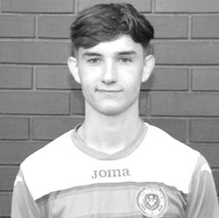
It’s been a while since our last home match so we have some birthdays to cover here.

Firstly, Adam Heagney was 22 on 11th February. Adam has been with us for three seasons now, making his debut back on 16th August 2016 at home to CB Hounslow United after joining from the Leatherhead Academy and racking up 119 appearances for our club as I write, with three goals to his credit. He had a brief spell at Guildford City but has spent most of that time with us.

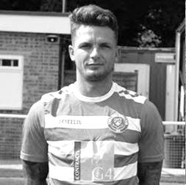
Adam started his Epsom career as a right back, but has found himself playing more centrally this season, usually in a holding midfield role, although is equally competent in the middle of the back four.

Next up is another versatile player as Tuesday, 19th March will be Reisse Griffin’s 29th birthday. He joined us from Cheam at the start of the 2015/16 season and made his debut at Windsor on 8th August 2015.

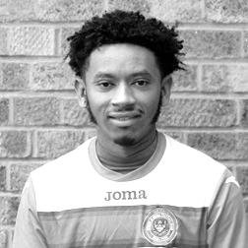
He seemed to find the step up from lower grade football quite easily and although he has had some work commitments over recent seasons Reisse has still made 138 appearances for our club with twelve goals, four of which have come this season. Reisse is another player that started in one position but has now converted to a left back, having been a right winger for many of his earlier appearances.

Finally this month, Louis Chin celebrates his 26th birthday on Tuesday 26th March. Louis joined us from Chessington & Hook United and made his debut on 8th December last year in the entertaining 4-4 draw at home to Bedfont & Feltham. Louis has been in and out of the side recently, but this is because he was ineligible for our club in the many cup ties we have had this season. He has now made nine appearances, most of which have come at right back, although he found himself in the centre of midfield last Saturday, following circumstances conspiring against us when we played Kensington Borough last Saturday. Congratulations guys!

Latest Results Grid
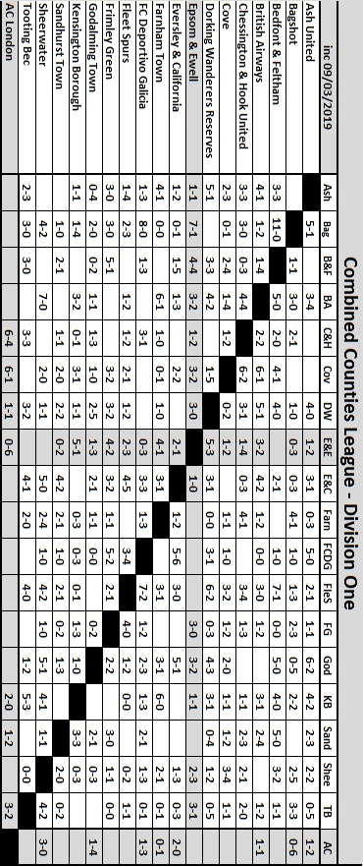

Player Sponsorship
Here is the latest list for 2018/19, with photos showing all of our players and Management that are available for sponsorship.

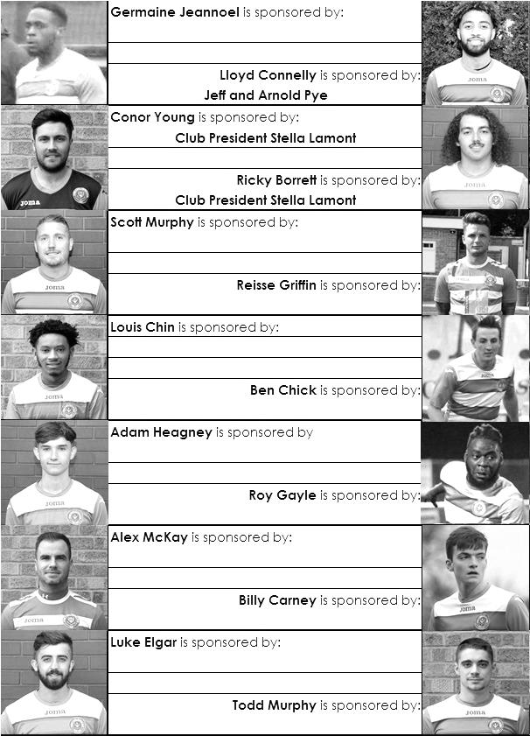

Sponsorship costs just £40 and it is easy to do. Just select a player who has not been previously sponsored and let a Committee Member know that you would like to sponsor them. Beware though. Until we have received the money it is possible for someone to jump in front of you, so don’t delay, sponsor today!

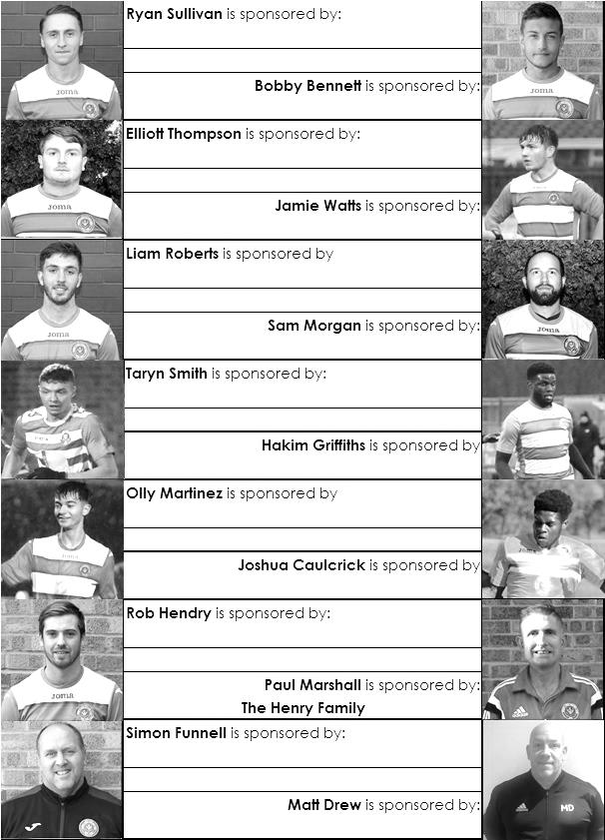

EL Records Premier Challenge Cup
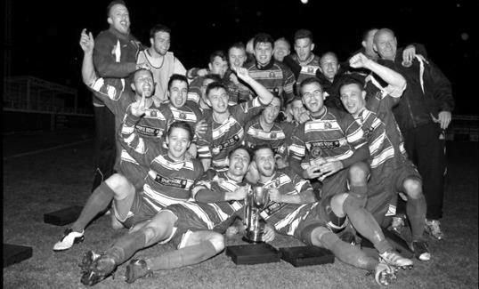
Second Round
Bedfont & Feltham | 2-0 | Tooting Bec
Sheerwater | 1-0 | Balham
Ash United | 2-3 | Fleet Spurs
Frimley Green | 0-2 | Guildford City
Godalming Town | 2-0 | Dorking Wanderers Reserves
Abbey Rangers | 3-0 | Redhill
FC Deportivo Galicia | 5-0 | AC London
Cobham | 0-3 | AFC Hayes
Abandoned after 88 minutes due to serious player injury - Match awarded to AFC Hayes
CB Hounslow United | 4-1 | Badshot Lea
Hanworth Villa | 2-1 | Sandhurst Town
Epsom & Ewell | 1-0 | Bagshot
Sutton Common Rovers | 4-2 | Southall
Chertsey Town | 3-2 | British Airways
Eversley & California | 1-5 | Knaphill
Banstead Athletic | 4-3 | Colliers Wood United
Spelthorne Sports | 2-1 | Raynes Park Vale
Third Round
FC Deportivo Galicia | 0-2 | Sutton Common Rovers
AFC Hayes | 0-1 | Bedfont & Feltham
Epsom & Ewell | 5-1 | Godalming Town
Sheerwater | 0-3 | Banstead Athletic
Guildford City | 0-2 | CB Hounslow United
Spelthorne Sports | 0-1 | Hanworth Villa
Knaphill | 3-1 | Fleet Spurs
Chertsey Town | 1-2 | Abbey Rangers
Quarter Finals
Abbey Rangers | 3-1 | Epsom & Ewell
Knaphill | 0-3 | Bedfont & Feltham
Sutton Common Rovers | 18/3 | Hanworth Villa
CB Hounslow United | 2-1 | Banstead Athletic

Esoteric League Division One Challenge Cup
First Round
Farnham Town | 0-1 | Godalming Town
Cove | 2-1 | British Airways
FC Deportivo Galicia | 2-1 | AC London
Second Round
Eversley & California | 2-3 | Bedfont & Feltham
Epsom & Ewell | 1-0 | Sandhurst Town
Tooting Bec | 4-1 | Ash United
Kensington Borough | 0-2 | FC Deportivo Galicia
Sheerwater | 2-3 | Chessington & Hook United
Fleet Spurs | 0-0 - 4-3p | Cove
Dorking Wanderers | 1-2 | Frimley Green
Godalming Town | 6-0 | Bagshot
Quarter-Finals
Tooting Bec | V | Frimley Green
Bedfont & Feltham | 1-2 | Epsom & Ewell
FC Deportivo Galicia | 5-1 | Godalming Town
Fleet Spurs | 0-0 – 4-3p | Chessington & Hook United

Surrey Premier Cup
First Round
Carshalton Athletic U19 | w/o Ash | Ash United
Shene Old Grammarians | 2-4 | Old Wilsonians
Lingfield | 5-1 | Horley Town Reserves
Alfold | 2-0 | Godalming Town
Epsom & Ewell | 5-0 | Knaphill U23
Reigatians | 0-4 | Frimley Green
Met Police Academy | 3-3 - 5-4p | FC Deportivo Galicia
Second Round
Ash United | 3-1 | Chessington & Hook United
Alfold | 0-1 | Nottsborough (holders)
Old Wilsonians | 1-6 | Lingfield
Sheerwater | 5-0 | Corinthian Casuals Reserves
Farnham Town | 4-1 | Westfield Reserves
Epsom & Ewell | 4-0 | Dorkinian
Met Police Academy | 7-3 | Dorking Wanderers Reserves
Bagshot | 1-3 | Frimley Green
Quarter-Finals
Ash United | 1-3 | Frimley Green
Met Police Academy | 4-2 | Epsom & Ewell
Farnham Town | 0-0 2-4p | Lingfield
Nottsborough (holders) | 1-1 7-6p | Sheerwater
Semi-Finals
Frimley Green | 19/3 | Nottsborough
Lingfield | V | Met Police Academy

FC Deportivo Galicia – History
We run 3 teams with ambitions of setting up a youth section.

1st Team: (DGL1) - Compete in the Combined Counties 1st Division

Res Team: (DGL2) - Compete in the Middlesex County 1st Division West

Vets Team:(DGLVets) - Compete in the West Middlesex Veterans League

Our first season at Step 6 has been a learning curve but we ultimately came away quite satisfied with reaching two semi-finals, one quarter final and a 12th place finish is not a bad return. With many lessons learnt we come into 2018/19 knowing what to expect and with targets.

We have a long and proud history that dates back to 1968 when the club was formed as a friendly gathering of early Galician immigrants. Since our birth we have steadily risen through the small minor Sunday Leagues and then in season 95/96 we made the leap to Saturday football.

At the point of promotion in 2016/17 we were the Middlesex County Football League’s longest serving club!

Our progression has been steady and had its ups and downs but more recently, following a 5-year plan put in place during season 2012/13 we have;

- achieved Adult Club Charter Standard Status, - steadily upgraded our facilities,
- increased our back-room staff,
- attracted exceptional players drawn to a unique style of football. In fact, many of our players are sons and grandsons of the founder members and probably the reason we have managed to keep the club going for so many years.
- applied to, accepted and played the FA Vase in 2016,17 & this season 2018
- applied for promotion to Combined Counties Step 6 1st Division for season 17/18
– Promoted as Middlesex County Premier Champions 2016/17
- ultimate ambition is to participate in The FA Cup.

Where we go from 17/18 will greatly depend on the continued support of our members but more so the possibility that we can attract individuals or companies that can help take us to the next level, which with our progression to Step 6 is very important for us. However, as most grass roots clubs find, this is probably the most challenging part of running a club like ours.

We are professionally run by experienced business & football individuals totally focused on doing things the right way. ALL dedicated high calibre volunteers.

Club Statistical History - (including Kensington Borough (A) on 09/03/19):
League: Played: 2,950, Won: 1,210, Drawn: 562, Lost: 1,178
For: 5,430, Against: 5,241, GD: plus 189 - Win Ratio 41.02%

CCL only: Played: 529, Won: 236, Drawn: 104, Lost: 189
For: 964, Against: 855, GD: plus 109 - Win Ratio 44.61%

Cup and Other (inc Abandoned Matches):
Played: 1,128, Won: 535, Drawn: 130, Lost: 455 Abandoned: 8
For: 2,450, Against: 2,111, GD: plus 339 - Win Ratio 47.43%

Under Simon Funnell: Played 24, Won: 15, Drawn: 3, Lost: 6
For: 62, Against: 40, GD: plus 22 - Win Ratio 62.50%

Total: Played 4,078, Won: 1,745, Drawn: 692, Lost: 1,633, Aban: 8
For: 7,880, Against: 7,352, GD: plus 528 - Win Ratio 42.79%

First Senior Match: 30th August 1924.
Lost 1-3 vs Dorking at our home ground at the time of Horton Hospital Grounds.

First Match Programme Issued: 15th September 1923.
Won 4-0 vs West Norwood Reserves - Friendly match at Horton Hospital Grounds.

Number of Official Home Grounds: Six.

Alexandra Recreation Ground 1918-1922,
Horton Hospital Grounds 1922-1925,
West Street 1925-1993,
Merland Rise 1993-2010,
Moatside 2010-2012,
High Road 2012- present.

Record Win: 12/10/1935 - 13-1 v Reigate Priory (H) - Amateur Cup.

Record Defeat: 14/02/1948 - 0-14 v Chelmsford City Reserves (A) - London League.

Longest Serving Manager: 1) Adrian Hill 853 1982-1985 & 1990-2003
2) Pat O’Connell 466 1973-1982
3) Lyndon Buckwell 407 2006-2014
4) Ricky Kidd 190 1986-1990

Record Appearances: 1) Graham Morris 658 1990-2004
2) Nigel Bennett 630 1989-2005
3) Tommy Tuite 582 1973-1987
4) Ernie Watkins 419 1945-1960

Record Goal Scorers: 1) Tommy Tuite 391 1973-1987
2) Reg Marlow 254 1924-1936
3) Kyle Hough 207 2007-2017
4) Jimmy Jones 148 1933-1945

Most Appearances in a season: Tony Coombe and Tommy Tuite - 59 in 1980/81.

Most goals in a season: Reg Marlow - 65 (at least) in 39 appearances in 1926/27.

Senior League Titles: 5 - 1925/26 Surrey Senior League - 1926/27 Surrey Senior League - 1927/28 London League - 1974/75 Surrey Senior League - 1977/78 Isthmian League Division Two

CCL Division One Club Directory
AC LONDON: Telephone: 0208 660 5491 - Colours: Orange/Black/Black
Ground: Whyteleafe FC - 15 Church Road, Whyteleafe. CR3 0AR

ASH UNITED: Telephone: 01252 344264 - Colours: Green with Red Trim/Green/Green
Ground: Shawfields Stadium, Youngs Drive, Shawfields Road, Ash, Aldershot. GU12 6RE

BAGSHOT: Telephone: 01252 623804 - Colours: Yellow/Black/Black
Ground: Fleet Town FC - Calthorpe Park, Crookham Road, Fleet. GU51 5FA

BEDFONT & FELTHAM: Telephone: 0208-890 7264 - Colours: Yellow/Blue/Blue

Ground: The Orchard, Hatton Road, Bedfont. TW14 9QT

BRITISH AIRWAYS: Telephone: 0208-890 7264 - Colours: Sky Blue/Navy Blue/Navy Blue
Ground: Bedfont & Feltham FC - The Orchard, Hatton Road, Bedfont. TW14 9QT

CHESSINGTON & HOOK UNITED: Telephone: 01372-602263 Colours: All Blue
Ground: Chalky Lane, Chessington. KT9 2NF

COVE: Telephone: 01252 543615 Colours: Yellow/Black/Black
Ground: Oak Farm, Squirrel Lane, Cove GU14 8PB

DORKING WANDERERS RES Telephone: 01306 400151 - Colours: Red & White Stripes/ Blue/ Red
Ground: Meadowbank Stadium, Mill Lane, Dorking. RH4 1DX

EPSOM & EWELL Telephone: 01737-553250 - Colours: Royal Blue & White Hoops/Royal Blue/Royal Blue - Ground: Chipstead FC, High Road, Chipstead. CR5 3SF

EVERSLEY & CALIFORNIA Telephone: 0118 973 2400 - Colours: - White & Royal Blue Hoops /Royal Blue/ Royal Blue - Ground: Fox Lane, off Reading Road, Eversley. RG27 0NS

FARNHAM TOWN Telephone: 01252 715305 - Colours: - Claret & Sky Blue /White/ Claret & Blue
Ground: Memorial Ground, Babbs Mead, West Street, Farnham. GU9 7DY

FC DEPORTIVO GALICIA Telephone: 0208 831 9067 - Colours: Royal Blue/Royal Blue/White
Ground: Bedfont Sports FC - Bedfont Sports Club, Hatton Road, Bedfont. TW14 9JR

FLEET SPURS Telephone: 01252 662810 - Colours: Dark Blue with Red Trim/Dark Blue/Dark Blue
Ground: Kennels Lane Farnborough. GU14 0ST

FRIMLEY GREEN Telephone: 01252 835089 - Colours: All Blue
Ground: Frimley Green Recreation Ground, Frimley Green Road, Frimley. GU16 6JY

GODALMING TOWN Telephone: 01483 417520 - Colours: Yellow/Green/Yellow
Ground: Wey Court, Meadrow, Godalming. GU7 3JE

KENSINGTON BOROUGH Telephone: 01372 360151 - Colours: All Blue
Ground: Leatherhead FC – Fetcham Grove, Guildford Road, Leatherhead. KT22 9AS

SANDHURST TOWN Telephone: 01252 878768 - Colours: Red & Black Stripes/Black/Black
Ground: Bottom Meadow, Sandhurst Memorial Park, Yorktown Road, Sandhurst. GU47 9BJ

SHEERWATER Telephone: 01483 772470 - Colours: Royal Blue & White/Royal Blue/Royal Blue
Ground: Woking FC - Laithwaite Community Stadium, Kingfield, Kingfield Road, Woking. GU22 9AA

TOOTING BEC Telephone: 0208 540 8843 - Colours: Black & White Stripes/White/White & Black
Ground: Raynes Park Vale FC – Prince George’s Playing Fields, Grand Drive, Raynes Park. SW20 9DZ

Combined Counties League Premier Division
Opponents All-time Records
incl Saturday  9th March | P | W | D | L | F | A | PPG | GD | Best  Win | Worst  Loss
Bagshot | 3 | 3 | 0 | 0 | 11 | 1 | 3.00 | +10 | 7-1 | -
AC London | 1 | 1 | 0 | 0 | 6 | 0 | 3.00 | +6 | 6-0 | -
FC Deportivo Galicia | 1 | 1 | 0 | 0 | 3 | 0 | 3.00 | +3 | 3-0 | -
Tooting Bec | 1 | 1 | 0 | 0 | 3 | 1 | 3.00 | +2 | 3-1 | -
Fleet Spurs | 1 | 1 | 0 | 0 | 3 | 2 | 3.00 | +1 | 3-2 | -
Bedfont & Feltham | 4 | 3 | 1 | 0 | 19 | 8 | 2.50 | +11 | 9-2 | -
Godalming Town | 6 | 5 | 0 | 1 | 15 | 9 | 2.50 | +6 | 5-1 | 0-3
Frimley Green | 12 | 9 | 1 | 2 | 37 | 9 | 2.33 | +28 | 7-1 | 2-4
Ash United | 21 | 11 | 4 | 6 | 50 | 32 | 1.76 | +18 | 6-0 | 0-3
Farnham Town | 18 | 9 | 4 | 5 | 31 | 29 | 1.72 | +2 | 3-0 | 1-4
Cove | 36 | 17 | 9 | 10 | 80 | 58 | 1.67 | +22 | 7-0 | 1-6
Chessington & Hook | 30 | 13 | 9 | 8 | 63 | 45 | 1.60 | +18 | 6-0 | 1-3
Sheerwater | 5 | 2 | 2 | 1 | 10 | 5 | 1.60 | +5 | 3-0 | 2-3
Dorking Wanderers Res | 2 | 1 | 0 | 1 | 6 | 5 | 1.50 | +1 | 3-0 | 3-5
British Airways | 2 | 1 | 0 | 1 | 5 | 5 | 1.50 | 0 | 3-2 | 2-3
Eversley & California | 2 | 1 | 0 | 1 | 2 | 2 | 1.50 | 0 | 1-0 | 1-2
Sandhurst Town | 16 | 7 | 0 | 9 | 28 | 28 | 1.31 | 0 | 4-0 | 1-3
Kensington Borough | 2 | 0 | 1 | 1 | 2 | 6 | 0.50 | 0 | - | 1-5

Combined Counties League – Division One
Tuesday, 12th March 2019 - Kick-off 7.45 p.m.
Epsom and Ewell  (Royal Blue & White hoops) | V |  | FC Deportivo Galicia  (Red / Green / Red)
Squad | NUMBERS |  | Squad
Conor Young |  |  | Kavi Luchowa
Louis Chin |  |  | Mo Turay
Luke Elgar |  |  | Adam Vigo
Reisse Griffin |  |  | Mo Cisse
Lloyd Connelly |  |  | Matt Surmon
Jamie Watts |  |  | Felipe Nogaledo
Adam Heagney |  |  | Anton Fernandez
Sam Morgan |  |  | Bruno Amritz
Todd Murphy |  |  | Ali Soussi
Ryan Sullivan |  |  | Mo Kelenchy
© Scott Murphy |  |  | Adil Hdiouad
Elliott Thompson |  |  | Mo El Gomri
Liam Roberts |  |  | Julian Lorenzo
Bobby Bennett |  |  | Diego Rodriguez
Rob Hendry
Roy Gayle
Olly Martinez
Jake Robinson
Hakim Griffiths
Ben Chick
Billy Carney
Simon Funnell | MANAGER |  | Leo Decabo
Matt Drew / Paul Marshall | ASSISTED BY
Matt Drew | COACHES |  | Jose Andon / Mick Hamaida
Chantelle Farrell | PHYSIO |  | Mani Pazo
REFEREE: R.Murphy
ASSISTANTS: R. van Niekerk, T.Ireland
Today’s match and match ball are sponsored by
regular supporter Alex McKay (senior)

OUR NEXT VISITORS TO HIGH ROAD
Fleet Spurs
Combined Counties League – Division One
Saturday, 6th April 2019 – 3.00 pm

